The Synod of Lakes and Prairies Presents

The Art of Transitional Leadership
Learning Ministry Skills for Today’s and Tomorrow’s Church
Pastors, Staff, COMs and Congregational Leaders
September 16-20, 2019

Christ the King Retreat Center in Buffalo, Minnesota

September 16-20, 2019
Whether it is a change in leadership or a changing community, leading a congregation through change is both challenging and rewarding. It takes knowledge, skill, resilience and spiritual strength to navigate the waters of change in a way that leaders and congregations thrive. This training is for individuals who are considering ministry in temporary settings (as an interim, transitional or designated pastor) or are experiencing ministry in these transitional times. Materials presented will include the basics of transitional ministry and will be of value to all congregational pastors regardless of their ministry setting. Best practices in transitional ministry include ways to enter the congregation and community, how to analyze a congregation’s strength and growing edges, and how to assist a congregation in moving toward a vibrant future. This training will delve into navigating change, the pastor as a spiritual interpreter of transition, family systems, mission focus ministry, conflict mediation, and building resiliency.

September 18-20, 2019
Congregational leaders seeking to serve God faithfully are invited to Part Two of the Art of Transitional Ministry Event. The Wednesday–Friday training is for ruling elders, deacons, and other congregational leaders. Workshops for this group will focus on the vital role you play in collaborating with pastors to lead congregations through ministry transitions. Participants can expect to learn about core value mission planning, leadership development, congregational systems, stewardship, and creating spiritual energy in congregations.

Workshops and Plenaries
Workshop Schedule
September 16-20, 2019  Week I – 30 hours Transitional Ministry Training |  |  | Instructors
Monday | Registration | 9:30 – 10:30 a.m.
 | Opening Worship/Welcome | 11:00 a.m.
 | Community Building | 11:30 – Noon
 | Lunch | Noon – 12:45 p.m.
 | Opening Plenary - Called to Change | 1:00 – 2:00 p.m. | SanDawna Ashley
 | Transitional Ministry Focus Points | 2:15 – 3:45 p.m. | Beth Wagner
 | Break | 3:45 – 4:00 p.m.
 | Why Change, When Change is Hard | 4:00 – 5:00 p.m. | James Gale
 | Dinner | 6:00 p.m.
 |  | 7:00 p.m.
 | Evening Prayer | 8:00 p.m.
Tuesday | Breakfast | 7:30 – 8:30 a.m.
 | Morning Worship | 8:45 – 9:00 a.m.
 | Emotional Intelligence | 9:00 – 10:00 a.m. | Beth Wagner
 | Break | 10:00 – 10:15 a.m.
 | A View from the Balcony | 10:15 – 11:15 a.m. | SanDawna Ashley
 | Community Conversation | 11:15 – Noon
 | Conflict Transformation | 1:00 – 2:00 p.m. | James Gale
 | Break | 2:15 – 2:30
 | Canoeing the Mountains | 2:30 – 3:45 | Beth Wagner
 | Family System and Differentiated Leaders | 4:00 – 5:00 p.m. | SanDawna Ashley
 | Dinner | 6:00 p.m.
 | Ministry Innovation | 7:00 p.m. | James Gale
Wednesday | Breakfast | 7:30 – 8:30 a.m.
 | Morning Worship | 9:00 a.m.
 | Rookie Smarts | 9:30 – 10:30 a.m. | Beth Wagner
 | Community Asset Mapping /Personal Reflection | 10:30 – Noon | SanDawna Ashley
Transformation Leaders/Transitional Ministers | Welcome/Plenary  Being Nice People Isn’t Enough: The Power of Unconscious Bias | 1:00 – 2:30 p.m. | Molly Casteel
 | Break | 2:30 – 3:00 p.m.
 | A Climate for Renewal | 3:00 – 4:00 p.m. | Panel Discussion
Transformation Leaders | Spiritual Leadership | 4:00 – 5:00 p.m. | SanDawna Ashley
Transitional Ministers | Contracting Getting A Call | 4:00 – 5:00 p.m. | Beth Wagner
 | Dinner | 6:00 p.m.
 | Yes and Improvisation and Ministry | 7:00 – 8:00 p.m. | Beth Wagner and SanDawna Ashley
 | Evening Prayer | 8:00 – 8:15 p.m.
Thursday | Breakfast | 7:30 – 8:30 a.m.
Transformation Leaders/Transitional Ministers | Daring Leadership | 9:00 – 10:00 a.m. | Jeff Japinga
Thursday Workshops
(Choose one workshop during each sessions)
Workshop Session One 11:00 a.m. – Noon
Size Matters in relationships, strategy, and change |  |  | SanDawna Ashley
Storytelling for God |  |  | Rachel Yates
The Extra Effort Required to Get Over Ourselves |  |  | Molly Casteel
Lunch Noon – 1:00 p.m.
Workshop Sessions II 1:00 – 2:00 p.m.
Creating A Culture of Generosity |  |  | TBA
Elephants in the Room (Brokenness/Pain/Secrets) |  |  | Beth Wagner
Expanding Ministry Through Podcasts |  |  | Mary Newbern-Williams
Workshop Sessions III 2:30 – 3:30 p.m.
Asking Powerful Questions of Ourselves and Congregations |  |  | James Gale
Thinking Fast and Slow |  |  | Jeff Japinga
Strength Finders (Assessment Required) |  |  | Beth Wagner
Open Space Conversations 4:00 – 5:30 p.m.
Dinner 6:00 – p.m.
Workshop Sessions IV 7:00 – 8:00 p.m.
Now What? Tools for Reducing the Harm of Unconscious Bias |  |  | Molly Casteel
Resiliency |  |  | Beth Wagner
Vocational Vitality |  |  | SanDawna Ashley
Evening Prayer 8:00 – 8:15 p.m.
Friday
 | Breakfast | 7:30 – 8:30 a.m.
Transitional Ministers | Discerning A Call to Transitional Ministry | 8:45 – 9:30 a.m. | James Gale and Beth Wagner
Transformation Leaders | Vision Casting and Next Steps | 8:45 – 9:30 a.m. | SanDawna Ashley
Transformation Leaders/Transitional Ministers | Peaks and Valleys | 9:30 – 10:00 a.m.
Closing Worship 10:30 – 11:15 a.m.

Presenters
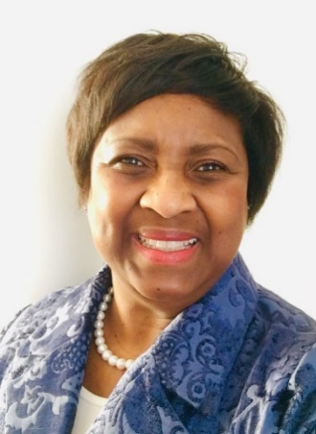
Rev. Dr. SanDawna Gaulman Ashley
Rev. Ashley is the Executive Presbyter for the Minnesota Valleys Presbytery. She has served as Assistant Stated Clerk, Manager for Call Process Support and Teaching Elders Ministries in the Office of the General Assembly. In her work, she provided training, consultation, coaching, and resources for presbyteries in support of congregations, COMs, call seekers and calling organizations. Additionally, her experience includes serving as the denomination’s Associate for Leadership Development with direct responsibility for equipping adaptive pastors, working with committees and assisting call seekers in vocational discernment. As the Associate for Gender and Racial Justice, Rev. Ashley, facilitated ministries and programs at all levels of the church that assisted the PC(USA) in becoming an inclusive, diverse, and racially just denomination. Her pastoral service includes serving as senior pastor and solo pastor of congregations in Pennsylvania, Delaware and Illinois. She has served as faculty for Transitional Ministry Training for five years. SanDawna holds degrees from Pittsburgh Theological Seminary, Doctor of Ministry (DMIN) with a concentration in leadership development and congregational transformation, Johnson C. Smith Theological Seminary Masters of Divinity in the Psychology of Religion and Pastoral Care (MDIV) and Georgia State University Bachelor of Social Work (BSW).

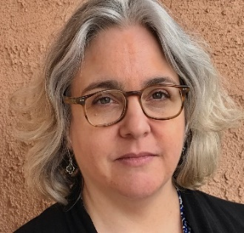
Rev. Molly Casteel
The Rev. Molly Casteel grew up in Tulsa, Oklahoma. Before seminary she worked in public health and community development. Ordained to national ministry positions, she has served in the Office of the General Assembly for 10 years and in the Mission Agency for 3 years previous. Her passions for equity, social justice and inclusion, sit beside her creative outlets in gardening, home improvement, arts and culture. A graduate of Princeton Theological Seminary, she lives in Louisville with her spouse and adorable rescue dog Huck.

Rev. James Gale
James is a graduate of The University of North Carolina at Chapel Hill and Columbia Theological Seminary. He served churches in North Carolina and Kansas before transitioning to his current position as Associate Executive of the Synod of Mid-America. James has completed Interim Ministry Training through Union Theological Seminary and most recently completed McCormick Theological Seminary's Certificate in Executive Leadership. He and his wife are the parents of two girls and all four are proud TarHeels.

Rev. Beth Wagner
I have just started my seventh transitional/interim position as Head of Staff/Lead Pastor at Yorkfield Presbyterian Church in Elmhurst, IL. Transitional work makes life interesting, it means a new location and new challenges every two years or so, and that is exciting for me and my family. I believe that at this time every church is in transition, my time with churches is just more defined as I fill in the in-between time of pastors. I have an umbrella and suitcase that sit in the chancel area of the different churches I serve as a reminder that we are all placed in particular places for a time, and eventually the winds will change and God will call us to another location. I am also blessed to serve the larger PC(USA) church by being team lead and facility for The Art of Transitional Ministry. Free time for Sir Dusty the cat, Honey Bear Cat and me often includes hanging out with a family that loves to camp included an adorable grandson and precious granddaughter or perhaps crafting (sewing, knitting and other fun creative things) or reading; everything from business books to mysteries to rhyming children’s books.

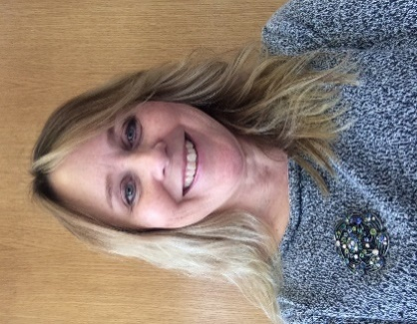
Elder Rachel Yates
Rachel Yates is the Presbytery Executive for the Presbytery of Milwaukee. In this role, she helps the leadership of the Presbytery to implement its vision through innovative and strategic initiatives. She began in this role in January 2018, after serving Presbyterian World Mission as its Associate Director for Program and a Church Support Associate. Yates is a ruling elder who practiced law in Colorado for 23 years. She and her husband have one daughter, who also lives in the Milwaukee area with her husband and son.

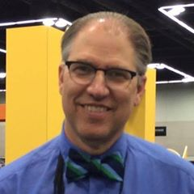
Rev. Dr. Jeffrey Japinga
Jeff as elected Executive Presbyter for the Presbytery of the Twin Cities Area in May 2017, for a five-year term, after serving two years there as transitional executive presbyter. He previously was a member of the faculty and dean of the doctor of ministry program at McCormick Theological Seminary, a PCUSA seminary in Chicago, and before that served for two decades as a member of the national staff of the Reformed Church in America. As a Northwestern University graduate, with a wife holding degrees from Iowa and Wisconsin and children with degrees from Michigan State and Wisconsin, he’s a Big Ten mismatch with Minnesotans, but still an okay guy.
Rev. Mary NewBern-Williams
Mary Newbern-Williams is an ordained PCUSA pastor with 30 years of experience in pastoral ministry, which includes Mid-Council and GA leadership. She is a graduate of Princeton Seminary (M.A.; M.Div.) and is the recipient of an Honorary Doctorate in Humane Letters. She is the Executive Presbyter for the Presbytery of Missouri River Valley. Mary is a published author of articles in “These Days,” “The Women of Color Study Bible,” “Aspire: The New Women of Color Study Bible,” and in 2014 she published her first novel under the pen name Ellen Amy Ryles, entitled “With Scars on My Soul.” Mary has been active in certain media projects since her teen years. She did voiceovers and commercials for local disc jockeys in high school; she co-hosted gospel radio programs, and conducted a podcast for 2 years. She is working on a current media project with local professionals in the Omaha Area.

Track One - Introduction to Transitional Ministry (Monday – Friday)
Participants in Track One completing the full 30 hours of training will meet the requirements for Week I Transitional Ministry Education. (If you want a certificate of completion, you must actively participate in all sessions in their entirety.) This course will meet September 16-20, 2019 (Monday-Friday). Fees Cover: materials provided for the education, 4 nights lodging in a double room, 4 breakfasts, 5 lunches and 4 dinners.

Track Two – Transformation Training for Church Leaders
Designed for Ruling Elders and others seeking to serve God faithfully in these challenging times. The Wednesday– Friday training is for ruling elders and other congregational leaders that key participants in their congregations. Workshops for this group will focus on core value mission planning, leadership development, congregational systems, stewardship, and creating spiritual interest in congregations.

REGISTRATION: https://synod-of-lakes-and-prairies.events.idloom.com/transitional-leader

COSTS: Tuition PLUS Room and Meals or Tuition PLUS Commuter rate

Track One
Tuition is $ 450/person
Single Room and Meals in $525/person
Double Room and Meals in $425/person
Commuter rate (meals only) $120
Track Two
Tuition is $200/person
Double Room and Meals is $225/person
Commuter rate (meals only) $60

